**ASSIGNMENT-II**

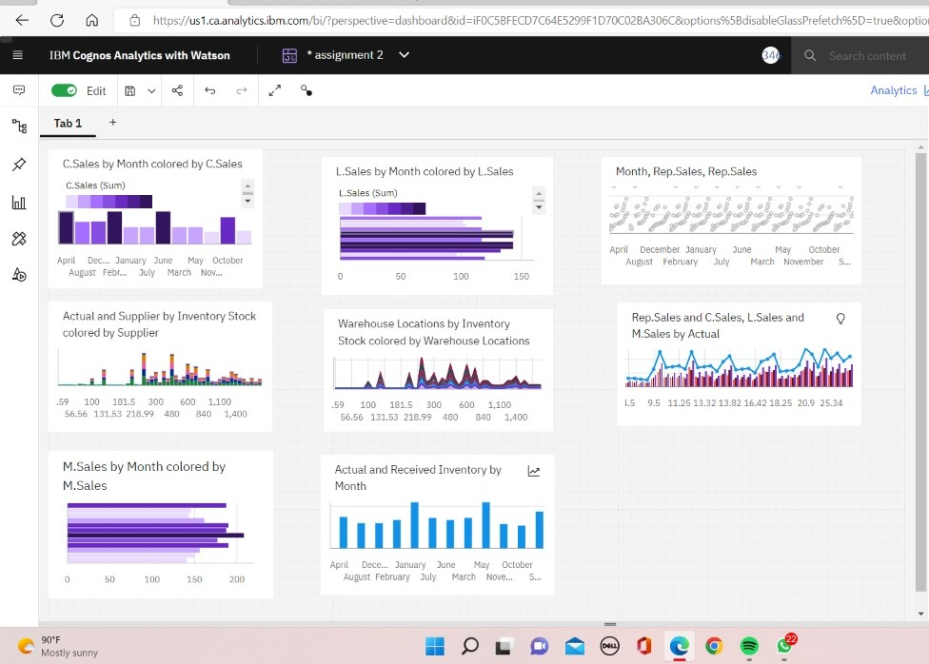

**LINk**

[**https://us3.ca.analytics.ibm.com/bi/?perspective=dashboard&pathRef=.my_folders%2FAssignment%2B2%2BMiruthula%2Bshri&action=view&mode=dashboard&subView=model000001836562b781_00000000**](https://us3.ca.analytics.ibm.com/bi/?perspective=dashboard&pathRef=.my_folders%2FAssignment%2B2%2BMiruthula%2Bshri&action=view&mode=dashboard&subView=model000001836562b781_00000000)